**Have your say on the redevelopment plans for the Council’s Perceval House offices**

The Plans go on display in the Ealing Broadway Shopping Centre next to the post office this coming **Thursday 6th (3.30-7.30 pm)** and again on **Saturday 8th (10am-2pm).**

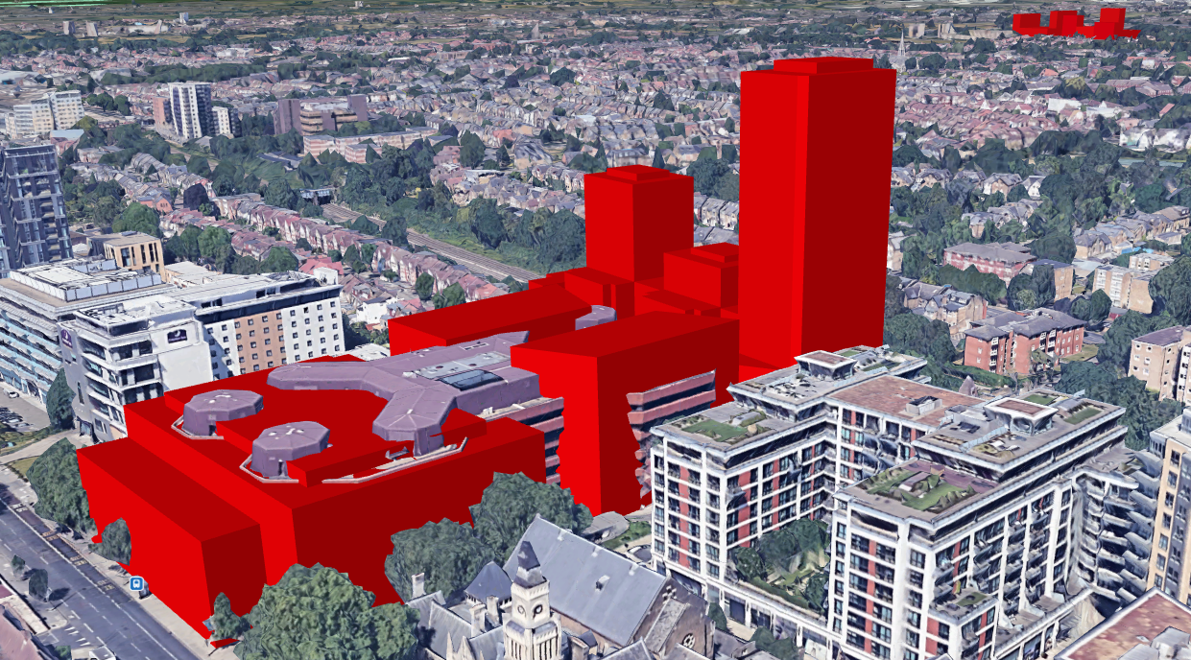 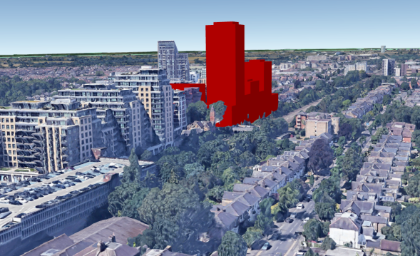

Illustrations* show that if this massive scheme goes ahead it will transform central Ealing. It will dwarf the Town Hall, dominate views from Walpole Park and Haven Green and provide further excuses for more residential towers all along the railway corridor.

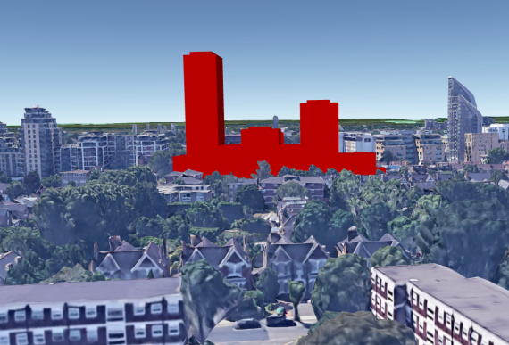 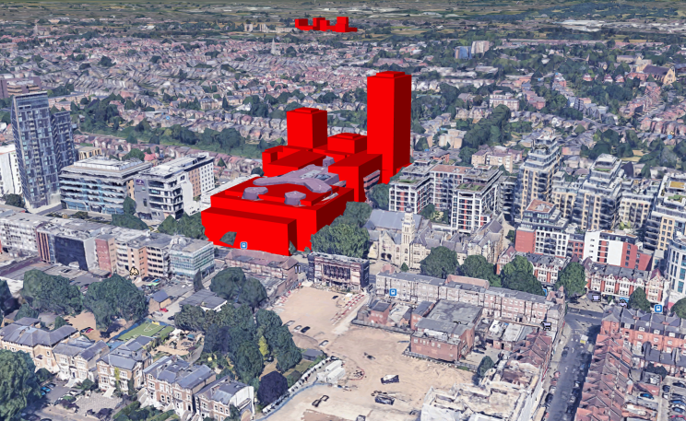

There has been next to no chance for the Ealing public to have their say on these plans. So go along and take this opportunity to do so.

* These illustrations are based on the site plan published but the developers and assume 3 metre storey heights to show the visual impact of what is proposed. State of the art software enable the 3 dimensional images of the new building to overlay Google maps. This is why some parts of the existing Perceval House that protrude outside the proposed building envelope are visible in two of the images.